Week 4 – Tutorial Questions

Option 1 – Continue with week 1’s Simscape
If you didn’t get round to finishing last sessions simscape exercise, feel free to keep working on this.

Option 2 – Simulate and optimise a sealed cabinet loudspeaker frequency response
A sealed cabinet loudspeaker can be modelled as a mass on a spring system. The driver/cone acts as the mass, the suspension/spider provides the spring stiffness and damping. The volume of air within the cabinet acts as a second spring in parallel with the suspension stiffness.

The radiated sound pressure from a loudspeaker is proportional to its acceleration. We can estimate the frequency response of the loudspeaker (not including sensitivity) by calculating the accelerance FRF of the mass spring system.

- Go online and find a loudspeaker driver with its corresponding spec sheet. Or use the driver below,
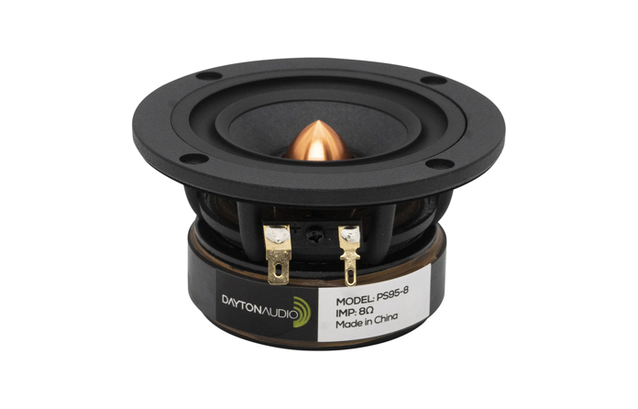

Parameter | Value
Resonant frequency | 119.8 Hz
Diaphragm Mass Inc. Airload (Mms) | 2.2 g
Mechanical Compliance of Suspension (Cms) | 0.79 mm/N
Mechanical Q (Qms) | 7.33
Surface area (S) | 28.3 cm²

- Verify the resonant frequency using the supplied mass and compliance values
- Convert the Q-factor damping into a viscous damping coefficient $c$ using the equation,
$$Q_{MS}=\frac{1}{c}\sqrt{\frac{M_{MS}}{C_{MS}}}$$
and then into the viscous damping factor $ζ$.
- Calculate and plot the accelerance of the driver with no added cabinet.
- Calculate the equivalent stiffness of a cabinet with a volume of your choosing.
- Calculate and plot the accelerance of the driver with an added cabinet (you should use a parallel spring)
- Play around with the cabinet volume to obtain a ‘nice’ frequency response.
- You might also try to add some cabinet damping… How does this effect the loudspeaker response?

Option 3 – Bottoms up!
We have seen that the humble beer/wine/gin bottle is in-fact a mass-spring assembly. The plug of air residing in the neck of the bottle acts as a mass. The volume of air in the bottle acts as a spring (with some damping). Let’s explore this further with some simple experiments…

You will need: at least one empty bottle (preferable the bottle should have a relatively sharp transition between its neck and the main volume), ideally a second bottle with the same volume, but a different size neck, a measuring jug, and a means of measuring the acoustic response (I use the phone app ‘Decibel X’.

Part 1 – Validate form of equation
We have seen that the resonant frequency of a system is equal to $ω=\sqrt{\frac{k}{m}}$. The mass of the neck is simply $m= ρ_{0}LS$. The stiffness related to volume by, $k=\frac{ρ_{0}c^{2}S^{2}}{V}$, with $V$ being the volume in m^3. We can begin to verify this equation by comparing the resonant frequency of the bottle with two different volumes.
- Measure the resonant frequency of the empty bottle
- Measure the resonant frequency of the half full bottle
- How does the frequency change relative to the volume? Does this agree with the equation?
- How might you improve the estimate of this relation?
- If you do manage to find two bottles, one with a different neck, try repeating this process using the different neck masses.

Part 2 – Estimate the resonant frequency of your bottles
- Using the volume and neck geometry, estimate the resonant frequency of your bottles. How do the results compare against measurement?
- What might the differences be caused by?

